AWS EC2 CHALLENGES
- Install nginx
- Sudo yum update -y
- Sudo yum install nginx
- Systemctl Start nginx
- Systemctl Status nginx
- Final Status Check: The service was confirmed to be active (running).
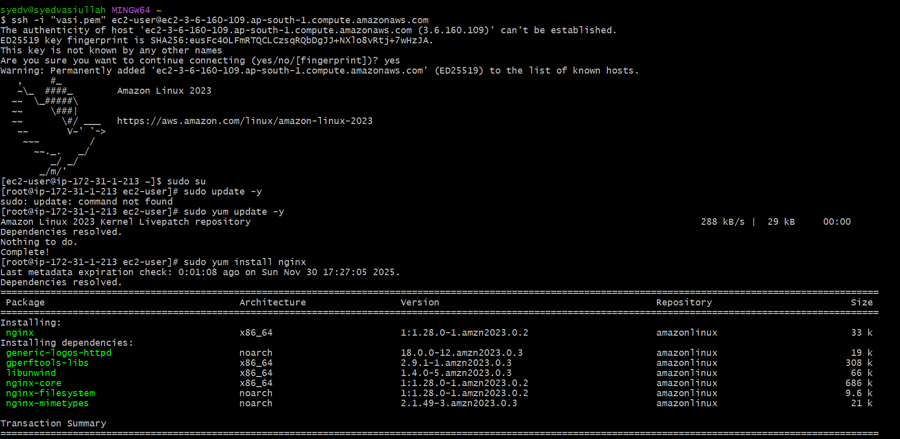
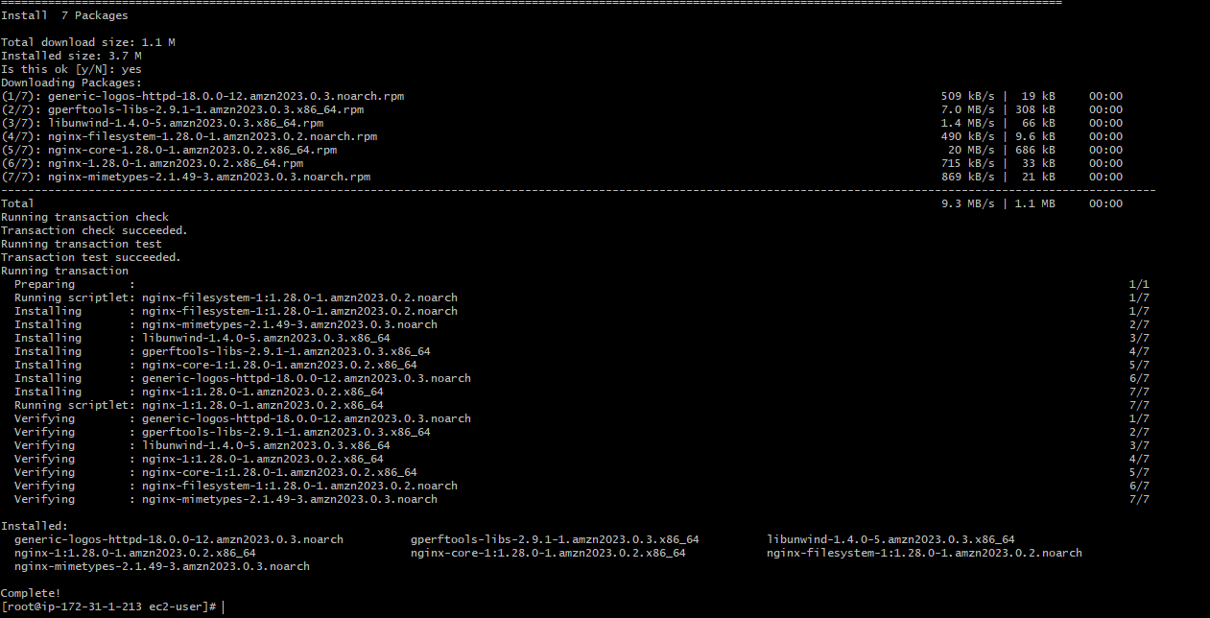
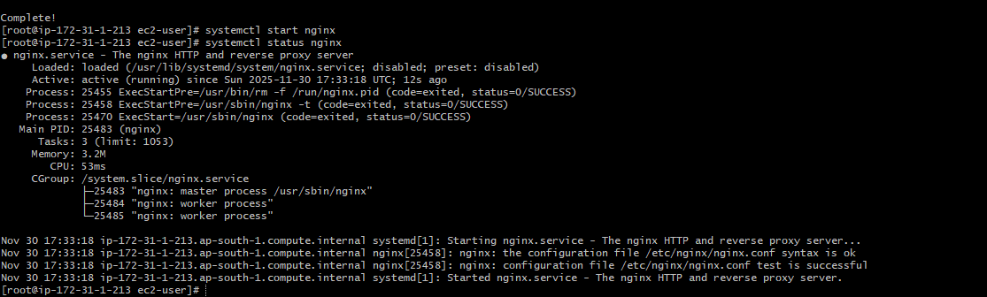
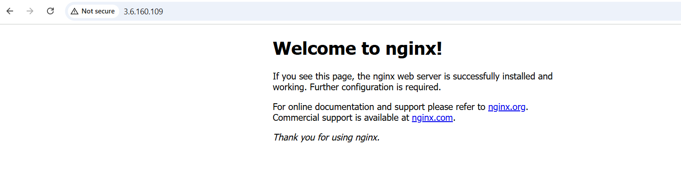2) Install docker
- Yum install docker

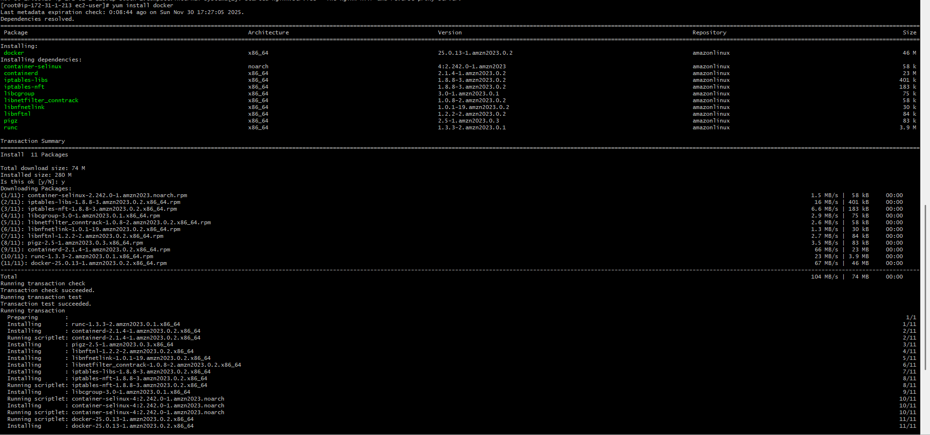
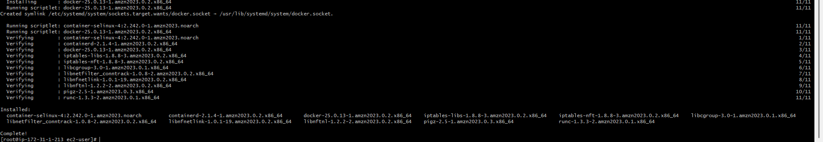

3)Install apache
- install Apache httpd
- Initial Status Check
- View Configuration
- Configuration Port Change
- port 8081
- systemctl stop httpd
- systemctl restart httpd
- systemctl enable httpd
- Final Status Check active running successfully configured and listening on port 8081.

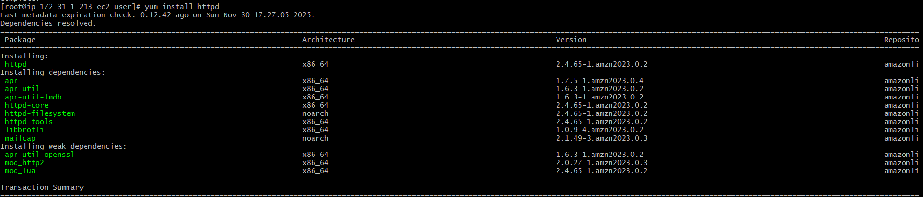

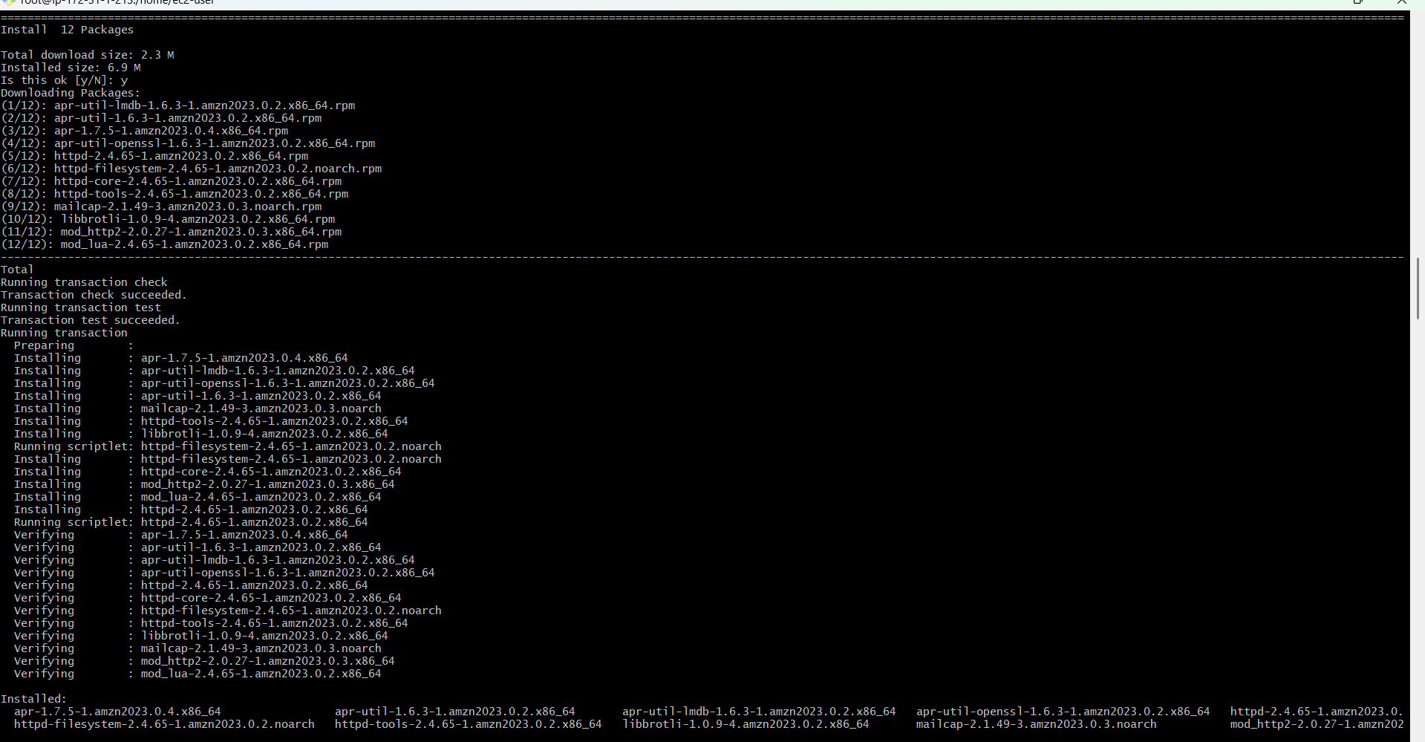
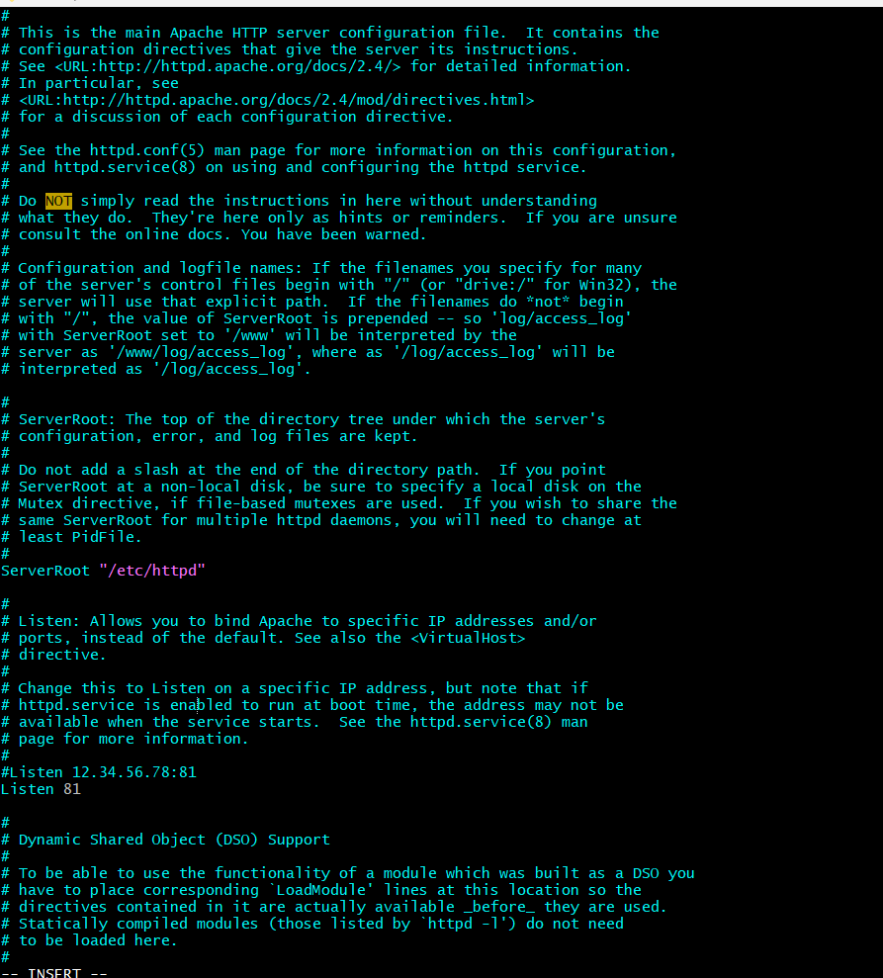
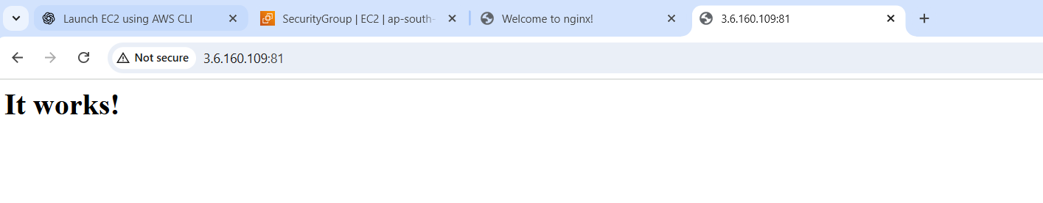

4)Install apache tomcat
- apache-tomcat-9.0.112.tar.gz) using the wget command.
- tar xvf into a directory named apache-tomcat-9.0.112
- run java -version
- Java was not installed
- using the command sudo dnf install java-17-amazon-corretto -y
- java -version
- Tomcat started

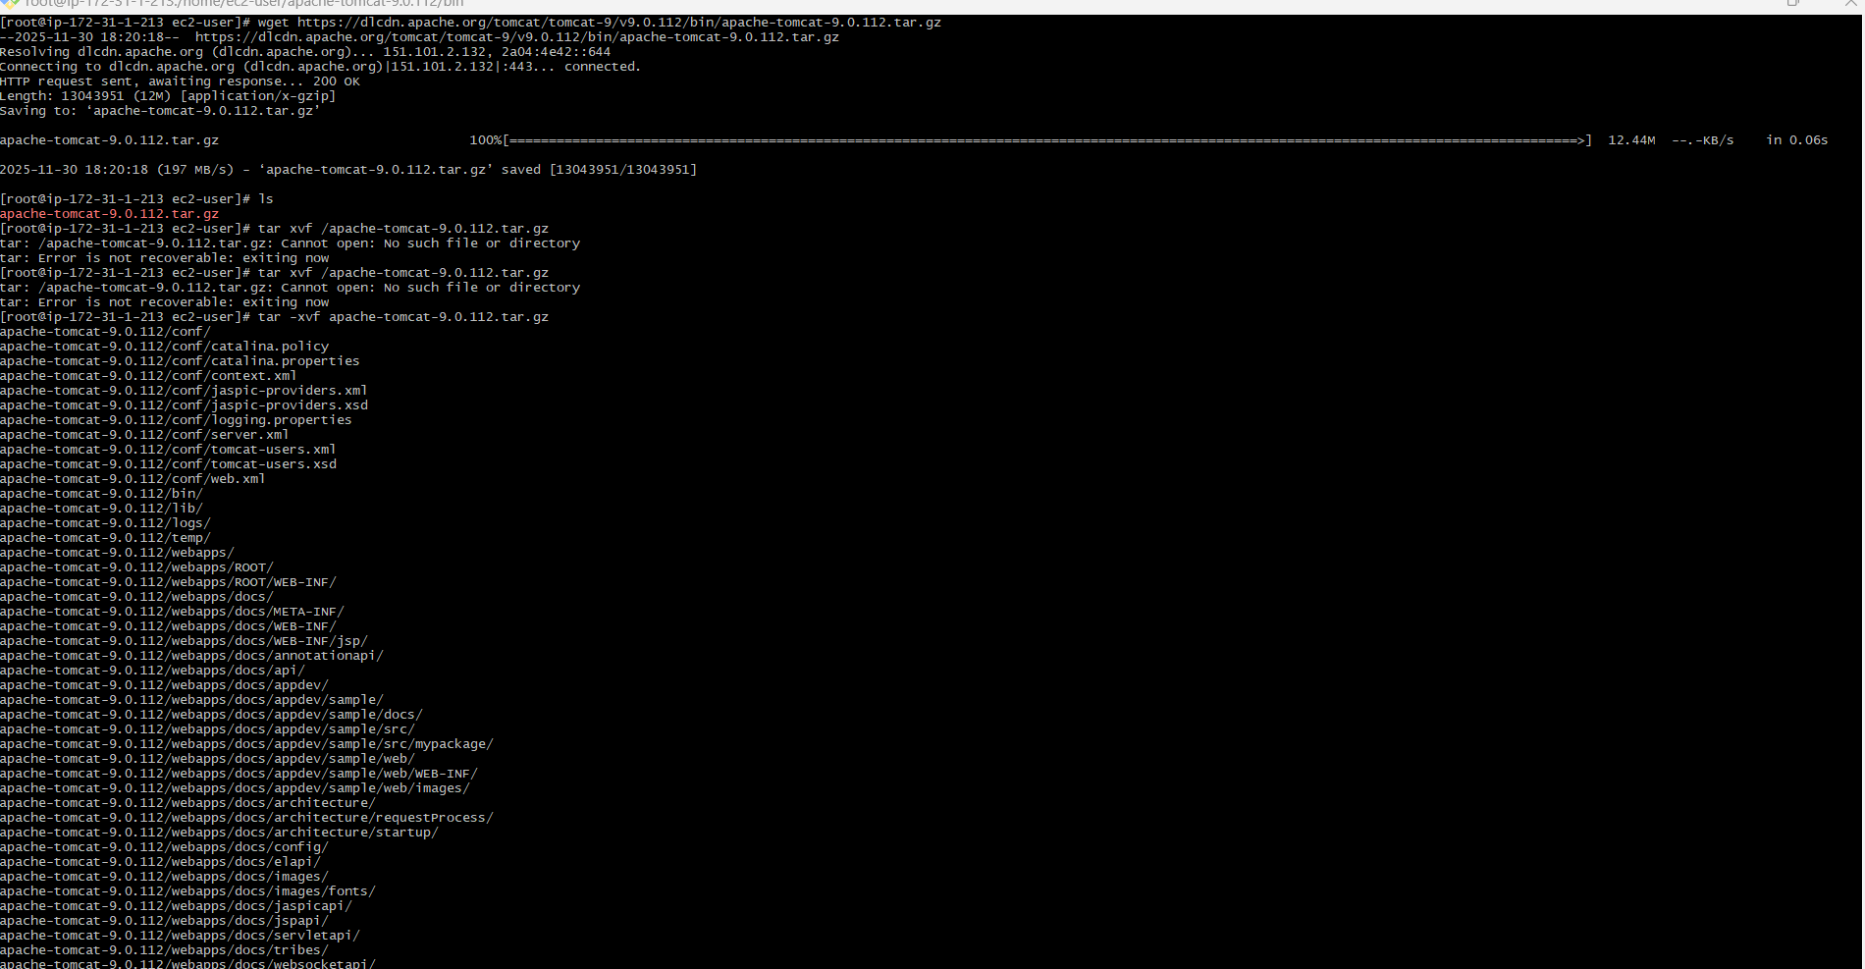
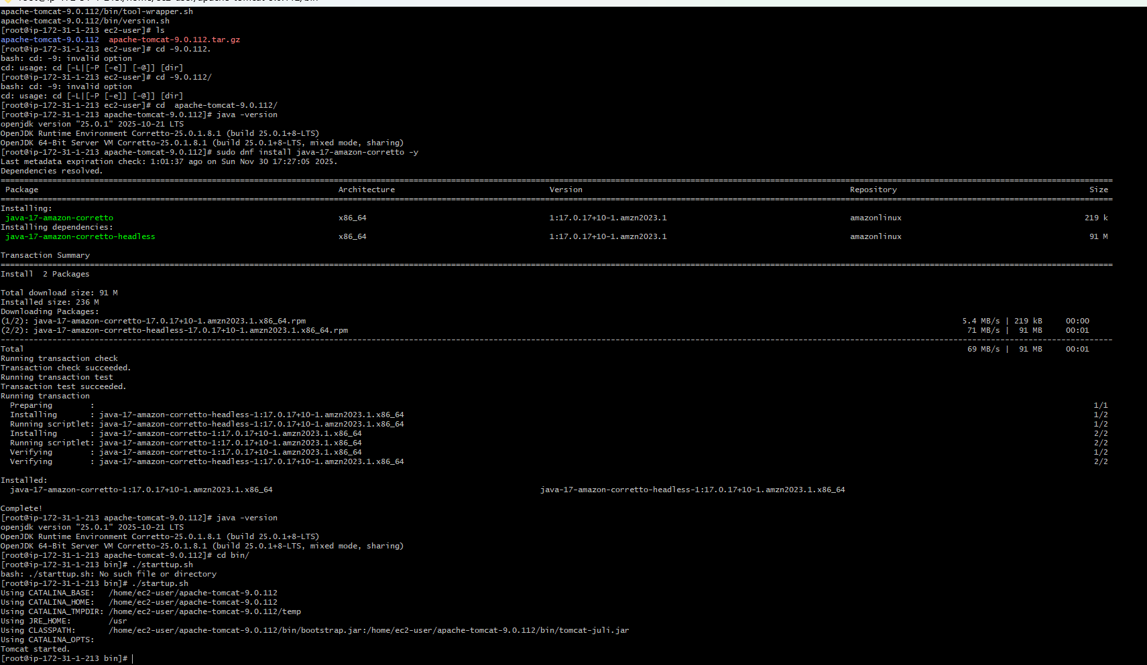

5) Install Jenkins
- Prerequisite to Install Jenkins is java.
- Download Jenkins Repo
- sudo wget -O /etc/yum.repos.d/jenkins.repo https://pkg.jenkins.io/redhat-stable/jenkins.repo
- sudo yum install Jenkins
- java -version
- ls
- vi Jenkins.service
- systemctl enable Jenkins.service
- systemctl start Jenkins.service
- systemctl status Jenkins.service
- yum install Java-17-amazon-corretto y
- Java –version
- Alternatives --config Java
- Systemctl enable Jenkins
- systemctl status Jenkins.service
- After plugin installation, the final Welcome to Jenkins! dashboard was reached
